Cars Overtaking 2D
Computer Graphics - Project Documentation
Date: 12 November 2026
Team Members: Chara Kirilidi, Afrodite Papazoglou, Kostis Tsesmelis

1. Project Concept
For this project, we decided to recreate a simple situation that we see in everyday
traffic: one car overtaking another. Our idea was to have several cars moving along a road, with one of them travelling faster and eventually overtaking the slower car in front of it. We wanted the movement to look natural, so instead of having the faster car simply pass through the other one, we included a lane-changing movement. The final scene includes four cars, with two of them travelling in the opposite direction.

2. How It Works
We first created the road and added lane markings to give the cars a clear space to move in. We then placed the car images in the scene and adjusted their positions and sizes. Each car has its own movement. The slower car moves forward at a constant speed, while the faster car moves at a higher speed. The other two cars travel in the opposite direction. The main part of the project is the overtaking sequence. As the faster car approaches the slower one, the program checks the distance between them. When the cars get close enough, the faster car starts moving sideways to change lanes. During this movement, the car also rotates slightly instead of moving only in a straight line. Once the slower car has passed, it gradually returns to its original lane. The positions are updated continuously, which makes the movement appear as an animation.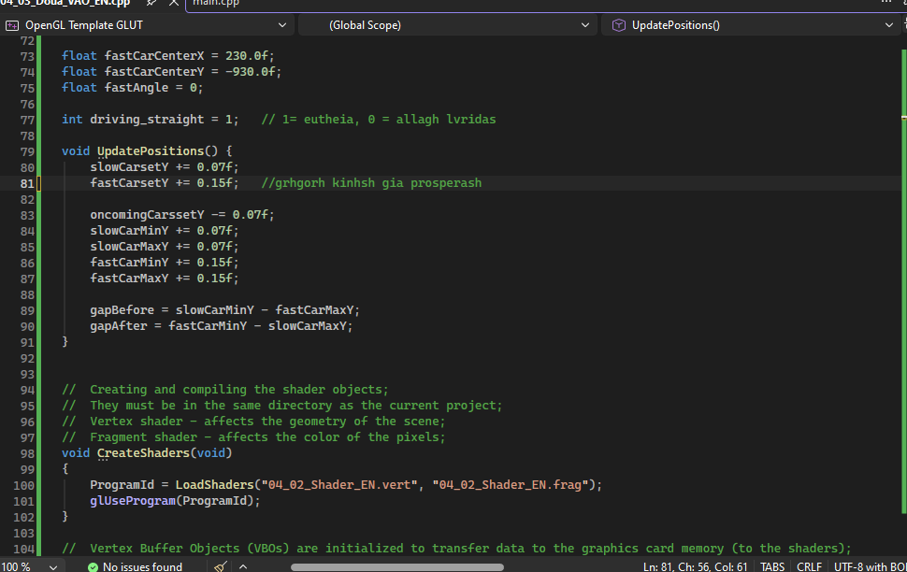

3. Transformations Used
The main transformations in our project are translation, rotation and scaling.
Translation is used for the movement of the cars along the road and for the sideways movement during overtaking.
Rotation is used when the faster car changes lanes. A small rotation helps make the overtaking movement look less rigid.
Scaling is used to adjust the scene to the drawing window.
By combining these transformations, we were able to create a simple traffic scene where the cars do more than just move in a straight line.

4. Originality and Difficulty
The most interesting part of our project was making the overtaking movement work. Moving a car forward is relatively straightforward, but making it approach another car, changing lanes, pass it and return requires several movements to work together. We also wanted the overtaking to depend on the distance between the cars, rather than having it happen at a completely random moment. Although the scene is simple, it helped us understand how different transformations can be combined to create a more realistic movement. We chose this idea because it allowed us to apply what we learned in class to a familiar situation.

